Theory of Computation-MCQ

1. What are the major families of automaton?

1. Finite-state machine, Pushup automata, Linear-bounded automata, Turning machine
2. Finite-state machine, Pushdown automata, Linear-bounded automata, Turing machine
3. Nonfinite-state machine, Pushdown automata, Linear-bounded automata, Turing machine
4. Finite-state machine, Pushdown automata, Nonlinear-bounded automata, Turing machine

Answer b

1. Finite automata is the ……………….. computation model/machine with ………………..

1. Simplest, limited memory
2. Simplest, extended memory
3. oldest, no memory
4. Advanced, limited memory

Answer a

1. Basic limitation of Finite Automata is that it

1. Cannot store large amount of information/instruction
2. Sometimes fails to recognize grammars that are regular
3. Sometimes recognizes grammars are not regular
4. None of these

Answer: a

1. Mark the true statement.

1. NFA is nonfinite automata
2. DFA can store a lot of instruction in its large memory
3. NFA can store a lot of instruction in its large memory
4. In NFA, the next state is always a member of the powerset of Q where Q is the set of state

Answer: d

1. Which machine/automata is appropriate: for a system that requires small memory but the system may stay in multiple states for a single input?

1. Deterministic finite automata
2. Nondeterministic finite automata
3. Deterministic nonfinite automata
4. Nondeterministic nonfinite automata

Answer: b

1. Transition function of DFA maps where 𝐸 represents alphabet and Q represents set of states?

1. 𝐸 𝑋 Q → 𝑄
2. 𝑄 𝑋 Ε → 𝐸
3. 𝑄 𝑋 Ε → 𝑄
4. 𝑄 𝑋 Ε → P(𝑄)

Answer: c

1. Minimum number of states required for a DFA to accept a string that contains odd number of 1s when  ?

1. 2
2. 3
3. 4
4. 1

Answer: a

1. Minimum number of transitions required for a DFA to accept a string that contains odd number of 1s when  ?

1. 3
2. 4
3. 5
4. Can’t be said

Answer: b

1. A= (*Q1*, Σ, d*1*, *q*1, *F1*) is a DFA where *Q1*= {*q*1, *q*2, *q*3, *q*4} and B= (*Q2*, Σ, d*2*, *q*2, *F2*) is another DFA where *Q2*= {*p*1, *p*2}. If M= (*Q*, Σ, d, *q*, *F*) is machine such that 𝑀 = 𝐴 ∪ 𝐵 then how many states will Q have?

1. 4
2. 12
3. 9
4. 8

Answer: d

1. A= (*Q1*, Σ, d*1*, *q*1, *F1*) is a DFA where *Q1*= {*q*1, *q*2, *q*3, *q*4} and B= (*Q2*, Σ, d*2*, *q*2, *F2*) where *Q2*= {*p*1, *p*2}. If M= (*Q*, Σ, d, *q*, *F*) is machine such that 𝑀 = 𝐴 ∪ 𝐵 then how many states will q have?

1. 1
2. 12
3. 9
4. 8

Answer: a

1. Transition function of NFA maps?
2. 𝐸 𝑋 Q → 𝑄
3. 𝑄 𝑋 Ε → 𝐸
4. 𝑄 𝑋 Ε → 𝑄
5. 𝑄 𝑋 Ε → P(𝑄)

Answer: 𝐷

1. Minimum of transitions/edges required for a NFA to accept a string that ends with a 0 when  ?
2. 2
3. 3
4. 1
5. Can’t be said

Answer: A

1. Minimum of states required for a NFA to accept a string that contains even number of 0 when ∑= {0,2}?
2. 2
3. 3
4. 4
5. 1

Answer: A

1. *N*1 = (*Q*1, Σ, d1, *q*0, *F*1) is a NFA that recognizes *A*. Now, we want to construct another NFA, *N*2 = (*Q*, Σ, d, *a*1, *F*) so that it recognizes *A*1*\*. Then how should we define Q?*
2. Q = {*q*0} È Q1
3. Q = { *a*1} È Q1
4. Q = {*a*1} È Q
5. Q = { *q*0} È Q

Answer: B

1. *N*1 and *N*2 are two NFAs such that *N*1 = (*Q*1, Σ, d1, *a*1, *F*1) recognizes *A*1 *N*2 = (*Q*2, Σ, d2, *b*1, *F*2) recognizes *A*2. Now, if we construct an NFA N to recognize *A*2°*A*1 what will be its final state?
2. F1
3. F2
4. F1 U F2
5. F U F1

Answer: A

1. The given DFA (as shown in the picture) accepts the language A where ∑= {1,0,2} and A is

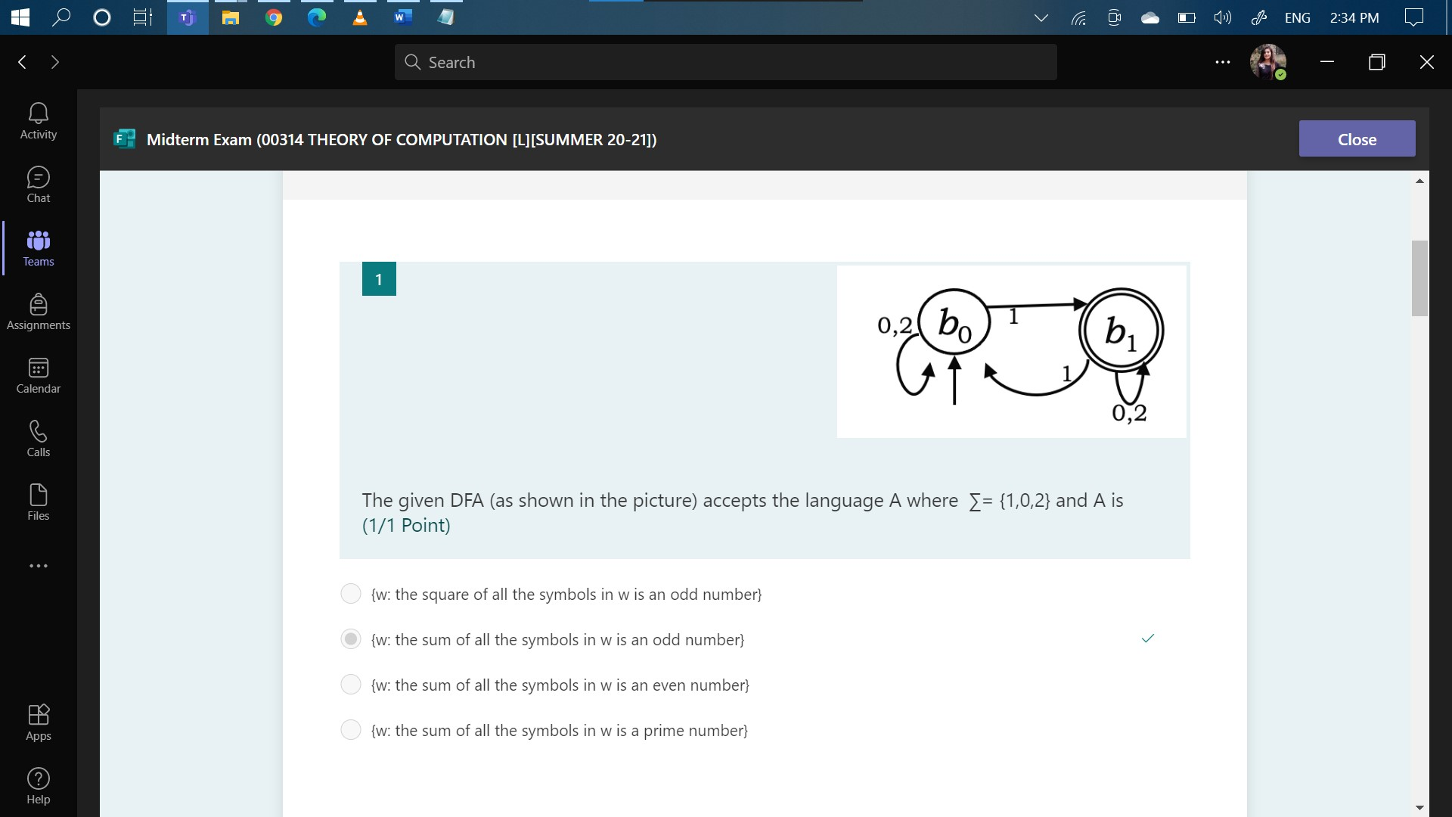

1. {w: the square of all the symbols in w is an odd number}
2. {w: the sum of all the symbols in w is an odd number}
3. {w: the sum of all the symbols in w is an even number}
4. {w: the sum of all the symbols in w is a prime number}

Ans: b

1. The given NFA (as shown in the picture) accepts the language A where ∑= {1,0} and A is

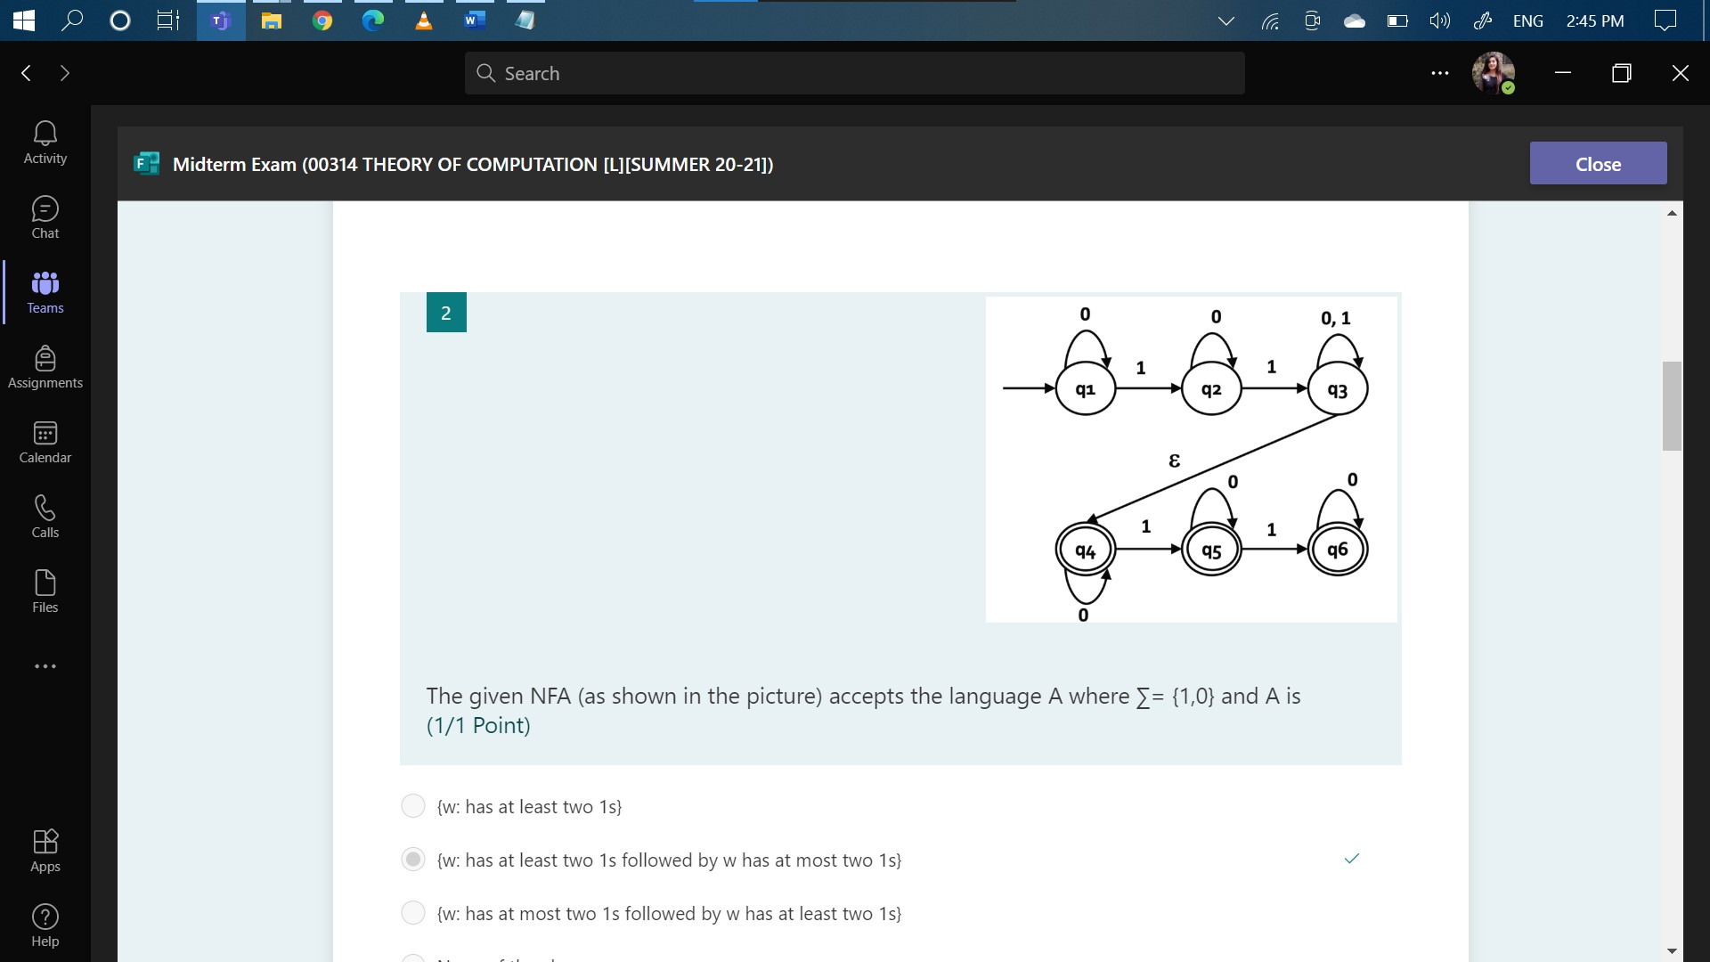

1. {w: has at least two 1s}
2. {w: has at least two 1s followed by w has at most two 1s}
3. {w: has at most two 1s followed by w has at least two 1s}
4. None of the above

Ans: b

1. Which machine is appropriate for a system that requires small memory, but the system stay in multiple states for a single input?
2. Deterministic finite machine
3. Nondeterministic finite machine
4. Deterministic nonfinite automata
5. Nondeterministic nonfinite automata

Ans: b

1. A= (Q1, Σ, delta1, q1, F1) is a DFA where Q1= {q1, q2, q3, q4} and B= (Q2, Σ, delta2, q2, F2) is another DFA where Q2= {p1, p2}. If M= (Q, Σ, delta, q, F) is a machine such that M=AUB, then how many states will Q have?
2. 4
3. 12
4. 9
5. 8

Ans: d

1. If E represent alphabet then transition function of NFA maps...
2. E X Q→Q
3. Q X E →P(E)
4. Q X E →Q
5. Q X E →2^Q

Ans: d

1. Minimum number of transitions required for a NFA to accept a string that ends with a 0 when ∑= {1,0}?
2. 2
3. 3
4. 1
5. None of the above

Ans: a

1. N1 = (Q1, Σ, delta1, a1, F1) is a NFA that recognizes A. Now, we want to construct another NFA, N2 = (Q, Σ, delta, q0, F) so that it recognizes A1\*. Then how should we define Q?
2. Q = {q0} U Q1
3. Q = {a1} U Q1
4. Q = {a1} U Q
5. Q = {q0} U Q

Ans: a

1. N1 and N2 are two NFAs such that N1 = (Q1, Σ, delta1, a1, F1) recognizes A1 and N2 = (Q2, Σ, delta2, b1, F2) recognizes A2. Now, if we construct an NFA “N” to recognize A1A2. Then, what will be its final state?
2. F1
3. F2
4. F1 U F2
5. F U F1

Ans: b

1. Minimum number of states required for a DFA to accept a string that contains odd number of 1s when ∑= {1,0}?
2. 2
3. 3
4. 4
5. 1

Ans: a